Dear Patient

Summary Care Record – your emergency care summary

The NHS in England is introducing the Summary Care Record, which will be used in emergency care.

The record will contain information about any medicines you are taking, allergies you suffer from and any bad reactions to medicines you have had to ensure those caring for you have enough information to treat you safely.

Your Summary Care Record will be available to authorised healthcare staff providing your care anywhere in England, but they will ask your permission before they look at it. This means that if you have an accident or become ill, the doctors treating you will have immediate access to important information about your health.

Your GP practice is supporting Summary Care Records and as a patient you have a choice:

• Yes I would like a Summary Care Record – you do not need to do anything and a Summary Care Record will be created for you.
• No I do not want a Summary Care Record – enclosed is an opt out form. Please complete the form and hand it to a member of the GP practice staff.
If you need more time to make your choice you should let your GP Practice know.

For more information you can contact the dedicated NHS Summary Care Record Information Line on 0300 123 3020 or visit the website at www.nhscarerecords.nhs.uk.

Alternatively contact our local Patient Advice and Liaison Service (PALS) on 0800 030 4563 or email them at pals@northstaffordshire.nhs.uk.

Additional copies of the opt out form can be collected from the GP practice, printed from the website www.nhscarerecords.nhs.uk or requested from the dedicated NHS Summary Care Record Information Line on 0300 123 2030.

You can choose not to have a Summary Care Record and you can change your mind at any time by informing your GP practice.

If you do nothing we will assume that you are happy with these changes and create a Summary Care Record for you. Children under 16 will automatically have a Summary Care Record created for them unless their parent or guardian chooses to opt them out. If you are the parent or guardian of a child under 16 and feel that they are old enough to understand, then you should make this information available to them.

Yours sincerely

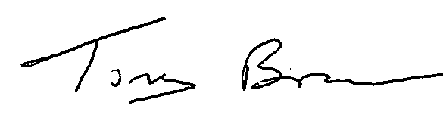

Mr Tony Bruce
Chief Executive

